Experiment: Student Information System

Create a simple cloud software application to run a c program to display the student information using any Cloud Service Provider to demonstrate SaaS with the template of student name, reg no, address, phone, age, courses, grades and attendance report, progress report, Semester mark sheet forms
Aim
To develop a cloud-based Student Information System for managing student details, academic information, and personal records.
The system helps maintain student information, monitor academic progress, and generate student reports efficiently.
Procedure
- Create a new application named Student Information System.
- Create Student Details, Course Details, and Academic Records forms.
- Add fields such as Student ID, Student Name, Date of Birth, Gender, Department, Course, Year, Email, Phone Number, Address, and Academic Status.
- Use Lookup fields to connect the Student Details and Course Details forms.
- Create reports to display student profiles, course-wise student lists, and academic records.
- Test the application by adding, updating, searching, and deleting student information.
- Publish the application and verify that all student records are stored and retrieved successfully.

IMPLEMENTATION
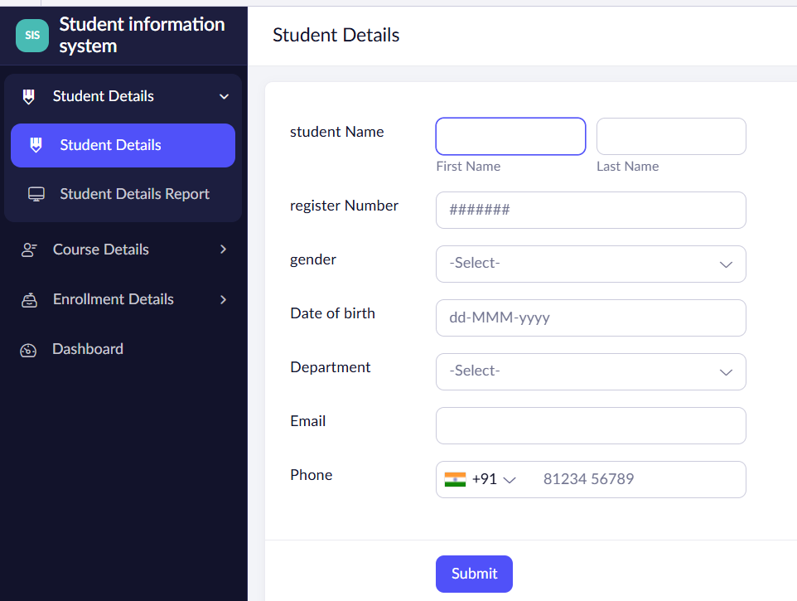
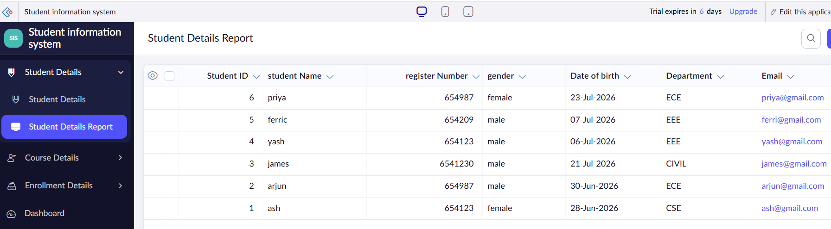
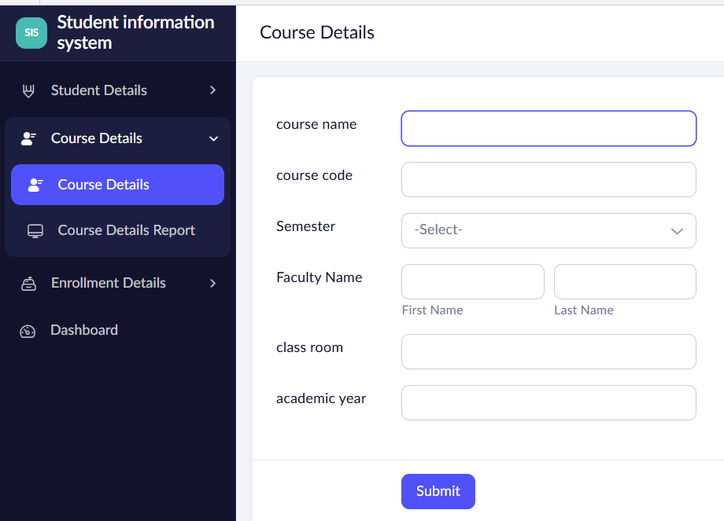
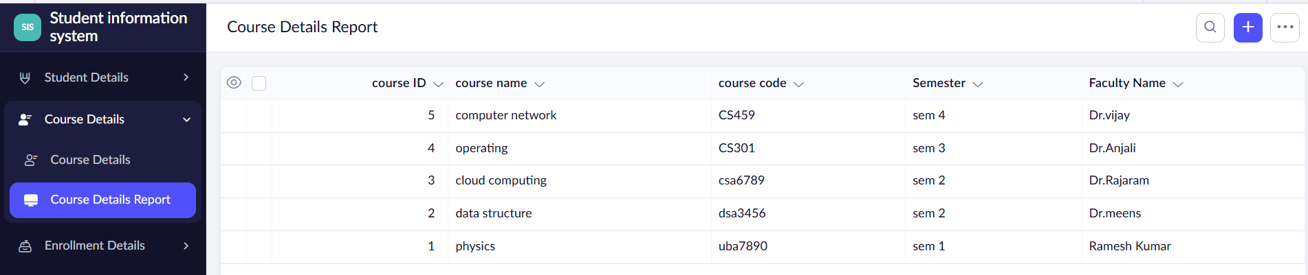

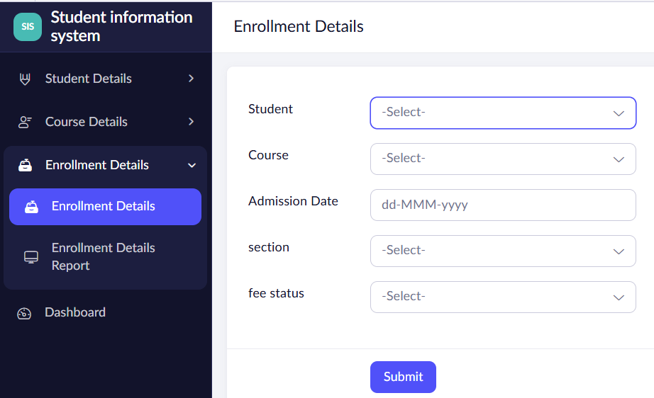
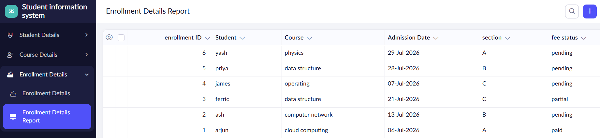
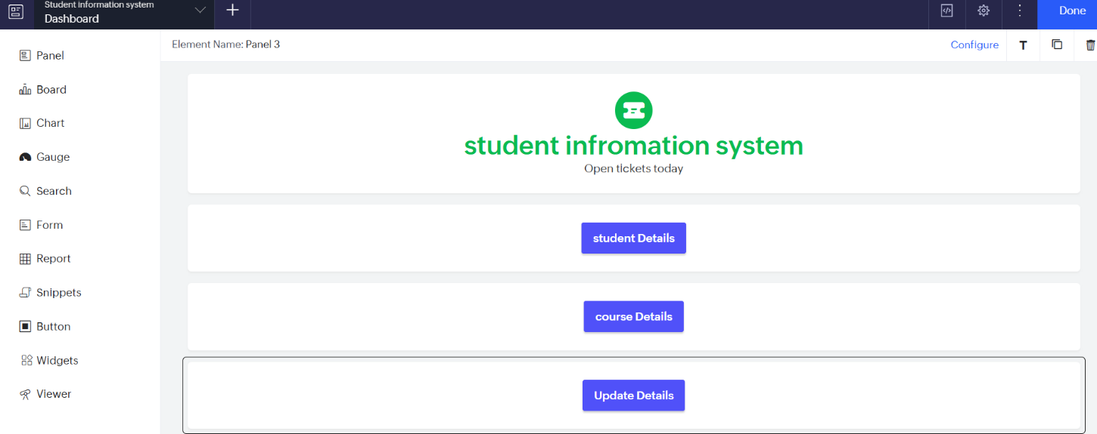
Result
A cloud-based Student Information System was successfully developed. The application enables institutions to manage student information, maintain academic records, generate reports, and access student data accurately and efficiently.

